
PRODUCTIVE

Microsoft Dynamics Snap
Customer Journal Snap-in
For Microsoft Dynamics™ AX 4.0 / 2007 Microsoft® Office system
Technical White Paper

February 16, 2007

Microsoft Dynamics Snap Sandbox

Table of Contents
EXECUTIVE SUMMARY 3
INTRODUCING MICROSOFT DYNAMICS SNAP 3
MICROSOFT DYNAMICS SNAP FOR CUSTOMER JOURNAL 3
FUNCTIONAL OVERVIEW 4
A 360º VIEW OF CUSTOMER 5
WORK OFFLINE 6
SYNCHRONIZING WITH MICROSOFT DYNAMICS AX 9
VERIFYING CHANGES THROUGH MICROSOFT DYNAMICS AX 4.0 WINDOWS CLIENT 10
HIGH LEVEL ARCHITECTURE 12
PRE-Requisites 12

EXECUTIVE SUMMARY
Many corporations implement business application systems like Microsoft Dynamics™ to automate their business processes. However, there are often times when employees are not able to connect directly with the system and yet still need access to the business essential data that resides within it. What if there were ways to enable those information workers to access the data in Microsoft Dynamics applications whenever and wherever they need it?

INTRODUCING MICROSOFT DYNAMICS SNAP
Microsoft Dynamics Snap applications do just that—they allow information workers to interact with Microsoft Dynamics business information, thereby increasing their productivity and enabling them to make decisions with confidence, all from within the Microsoft Office applications they are most comfortable with and with which they are most familiar. Now all employees can get timely and accurate data out of or into the Microsoft Dynamics applications without ever having to leave Microsoft Office. Microsoft Dynamics Snap applications help companies maximize their investment in Microsoft technology by delivering the power of the Microsoft Dynamics business applications to every single employee.

MICROSOFT DYNAMICS SNAP FOR CUSTOMER JOURNAL
The Customer Journal Snap-in enables a sales professional to have more productive sales meetings by allowing him to capture all the information he needs about a particular customer, take that information with him, view it and update it, all while remaining offline from the Microsoft Dynamics™ AX system. It does this by capturing the customer information in a Microsoft Office InfoPath® 2007 form that pulls the data from Microsoft Dynamics AX 4.0. This allows the salesperson to:
- Get a holistic view of a customer’s relationship with his company
- Add / Edit information in the InfoPath form
- Update the edits in Microsoft Dynamics AX when reconnected

The Customer Journal Snap-in gives you the ability to capture vital data from the Microsoft Dynamics AX system and then refer to it from within the Office environment when offline. This has many benefits. It helps you:
- Increase the productivity of meetings with customers providing access to important information when you need it
- Increase the accuracy of your records by allowing you to update them while offline
- Minimize duplication of effort and possible errors in data entry by allowing you to upload those changes when you are back online

Customer Journal Snap-in works with Microsoft Dynamics AX 4.0 and Microsoft Office 2007 and is distributed at the Microsoft Dynamics Snap site on GotDotNet.com.
This white paper is divided into two sections, the first to help you understand the features of the Customer Journal Snap-in and the second to provide an overview of the technology used to help you create your own solutions:
- Functional overview: This section explains the Customer Journal Snap-in functionality.
- High level architecture and customization: This section explains the various technologies used and how they work together to provide the functionality. Partners may use a similar framework to build additional scenarios.

FUNCTIONAL OVERVIEW
A Sales professional spends a lot of time outside the office meeting with customers. Most of these meetings involve discussions around the on-going transactions with the customer and potential opportunities that may arise in the future. To optimize the time spent at these meetings, it is essential for the Salesperson to know as much as possible about the history of the relationship with the customer and the status of all on-going transactions. Additionally, any commitments he makes during his discussion with the customer need to be accurately recorded for future reference.
The Customer Journal Snap-in allows a Salesperson to quickly view and capture a 360º view of his organization’s relationship with a customer from data in the Microsoft Dynamics AX system. Using a form created in Microsoft Office InfoPath 2007, he can take this data with him and view, add to or edit that data all while off of the network. Once back on the company network, he can easily update Microsoft Dynamics AX .
The next few screenshots demonstrate how easy it can be for a Sales Rep to have all the information he needs at his fingertips, before, during and after the sales meeting with the customer. Consider a scenario where you are a salesperson preparing to leave for a meeting with a key account that you manage.

A 360º VIEW OF CUSTOMER
All that you need to do to get a complete summary of all recent interactions with the customer is to open the Microsoft Office InfoPath form, click Connect to AX button, search for the customer by entering first few characters of his name in the Customer Account Name text box on the form and click Go.
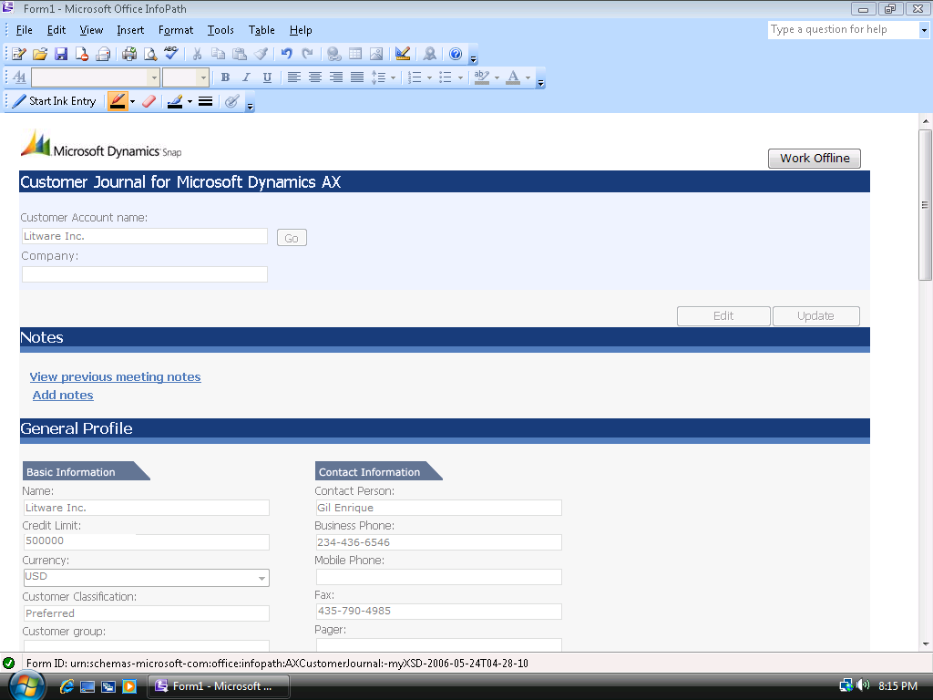
The fields on the InfoPath form will show data from Microsoft Dynamics AX pertaining to the customer. The information available includes general profile data like account number, account details, general payment and delivery details, etc. to transactional information like currently active sales quotations and orders, recently won and lost quotations, recent service requests, etc.

WORK OFFLINE
All you need to do to enable you to take this relevant information with you to the customer meeting is name the form and save it on your machine.
View Customer Information
Simply open the saved form to access the data during your meeting. There is no need to connect to your company’s Microsoft Dynamics AX system.
Add and Edit Data
Click the Edit button on the form to make changes to data. Note that not all fields on the form can be edited. Non-editable fields are differentiated in appearance from the editable ones. You can make changes, save, close and re-open the form repeatedly as you access and edit information.
In our scenario, say the customer you are meeting talks about a new Sales Quotation. To add this information to the form, go to the Sales Quotations summary section in the form and click on the Add quotation button while the form is in Edit mode. This adds a new blank record to the Active quotations table. Fill the Name, Discount%, Expiry date, Prognosis and Sales responsible fields in the new Sales quotation record. To enter one or more line items as part of this sales quote, click on the newly added sales quotation row in the Active quotations section and then click on the Add quotation Line button in the Items grid. The Item Name field in the Line items table should be keyed in manually. Just type in the initial few characters of the item name and leave it at that. The Value and Qty fields are mandatory for adding the line item to a quote. When the form’s contents are finally updated to Microsoft Dynamics AX 4.0, a dialog box showing the list of items that matched the characters entered for the Item name pops up. Choose the appropriate item from this dialog box.

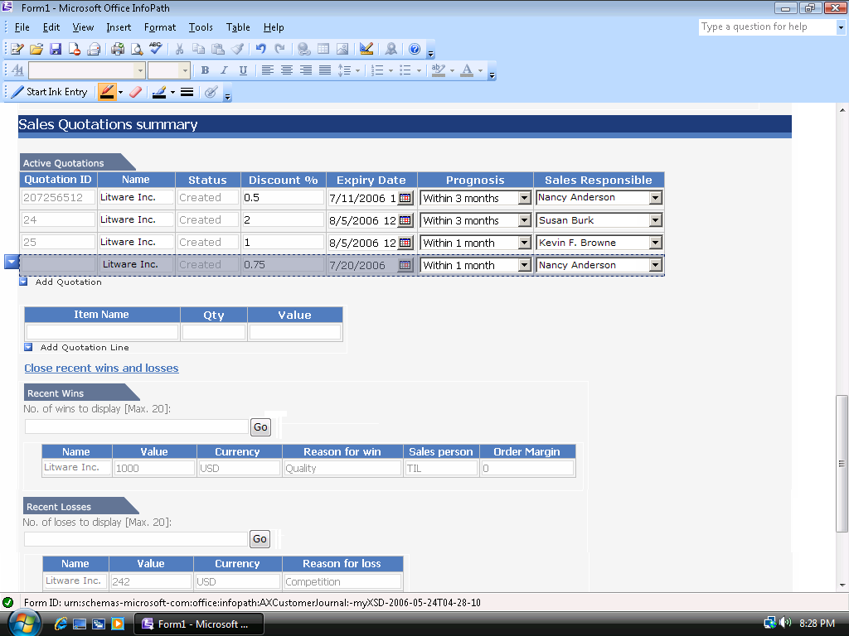
You can similarly add or edit service requests, Activities and customer profile data in the form. These changes can be updated in Microsoft Dynamics AX once you are reconnected to your company network. Fields like ‘Service Request Number’, whose values are automatically set by Microsoft Dynamics AX are not editable offline and are filled automatically once you synchronize the changes with Microsoft Dynamics AX.
Taking Notes
You can use the Customer Journal to save and view the meeting notes for last 5 meetings with the customer. To see previous meeting notes, click on the View Previous meeting notes link in the form. The last five meeting notes are collated vertically and presented in a read-only panel in this section. To add new notes, click Add notes link. Once you have finished adding new notes, fill in the Subject, Venue, Date and Attendees fields of this section. When you synchronize the form’s contents with Microsoft Dynamics AX (as described in the next section), these new notes are saved in Microsoft Dynamics AX as notes attached to the customer account.
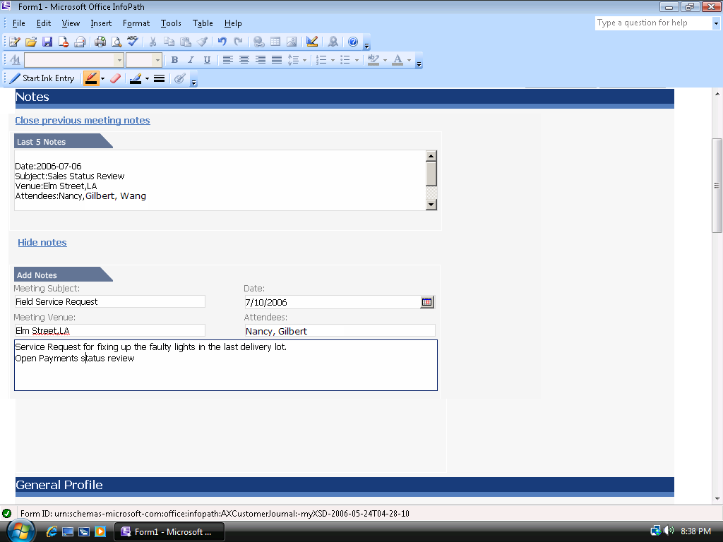

SYNCHRONIZING WITH MICROSOFT DYNAMICS AX
Once you are back from the meeting, open the saved InfoPath form where you made the changes during the meeting and click Connect to AX button and then click Update. A pop-up dialog opens, summarizing the changes made since the last refresh. You can review the changes and click Yes to confirm. The changes are updated in the Microsoft Dynamics AX system.
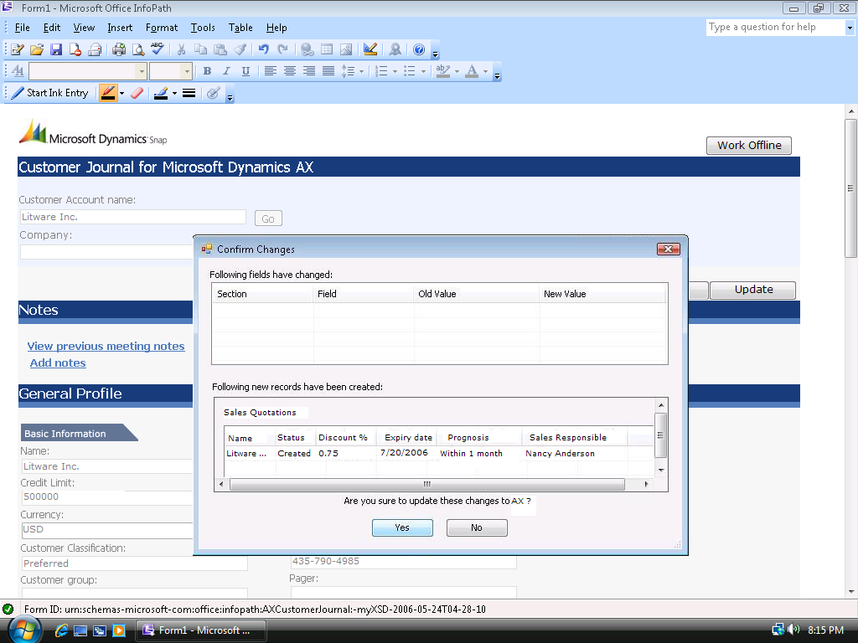

VERIFYING CHANGES THROUGH MICROSOFT DYNAMICS AX 4.0 WINDOWS CLIENT
The changes made through the Customer Journal form can be verified back in Microsoft Dynamics AX 4.0. The table below gives useful pointers on locating these changes using the Microsoft Dynamics AX 4.0 Windows client.

 Menu  Submenu  Forms  Buttons

Scenario | Microsoft Dynamics AX 4.0 Verification points
Making changes to the form’s contents | Accounts Receivables → Customers  Verify tab pages such as Overview,setup,Payment etc.
Adding a new Sales Quotation | Accounts Receivables → SalesQuotations
Adding a new Service Order | Service → Service Orders
Adding a new activity | CRM → Activities  OR  Customers → Inquires → Business Relations → Activities
View previous meeting notes and adding new notes | Accounts Receivables → Customers  Select the particular customer record. Click Tools → Document Handling in the menu bar

HIGH LEVEL ARCHITECTURE
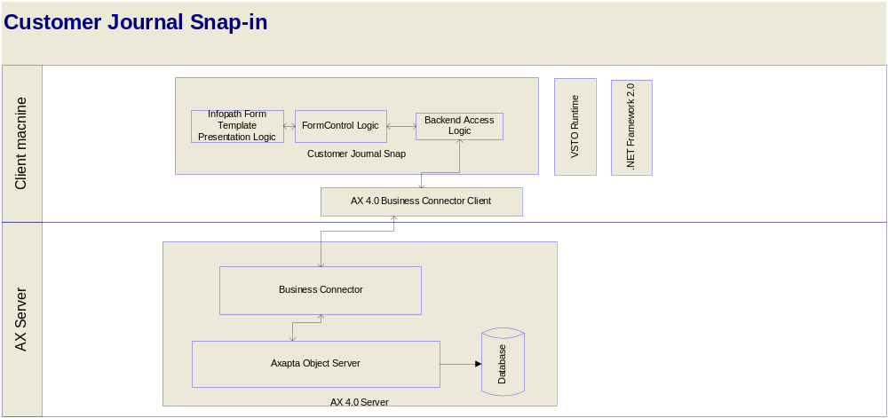

After you install the Microsoft VSTO 2005 SE Runtime and run the Customer Journal Snap-in installer, it copies the Microsoft Office InfoPath form template to the machine and registers it. InfoPath now recognizes the form template and can run the form-control customizations embedded in it. The form template’s presentation logic is tied to the backend via this assembly using event handlers tied to the form control logic using a thin backend access logic. The backend access logic talks to the Microsoft Dynamics AX 4.0 Object Server using the API provided by the .NET Business Connector Client of Microsoft Dynamics AX 4.0 installed on the same box as the snap-in. The Form Control logic layer binds the results from the backend, retrieved via the Backend access logic to the form controls in the required fashion.

PRE-Requisites
- Microsoft InfoPath 2007 should be installed
- The user should be a local admin on the machine and should have permissions and access to the Microsoft Dynamics AX 4.0 server
- Microsoft .NET Framework 2.0 should be installed on the system
- Microsoft VSTO 2005 SE Runtime should be installed on the system
- .NET Business Connector for Microsoft Dynamics AX 4.0 should be installed on the system
For more details on the pre-requisites and configuration requirements, please refer the installation guide in the setup package.

The information contained in this document represents the current view of Microsoft Corporation on the issues discussed as of the date of publication. Because Microsoft must respond to changing market conditions, this document should not be interpreted to be a commitment on the part of Microsoft, and Microsoft cannot guarantee the accuracy of any information presented after the date of publication.
This White Paper is for informational purposes only. MICROSOFT MAKES NO WARRANTIES, EXPRESS, IMPLIED, OR STATUTORY, AS TO THE INFORMATION IN THIS DOCUMENT.
Complying with all applicable copyright laws is the responsibility of the user. Without limiting the rights under copyright, no part of this document may be reproduced, stored in or introduced into a retrieval system, or transmitted in any form or by any means (electronic, mechanical, photocopying, recording, or otherwise), or for any purpose, without the express written permission of Microsoft Corporation.
Microsoft may have patents, patent applications, trademarks, copyrights, or other intellectual property rights covering subject matter in this document. Except as expressly provided in any written license agreement from Microsoft, the furnishing of this document does not give you any license to these patents, trademarks, copyrights, or other intellectual property.

© 2006 Microsoft Corporation. All rights reserved.
Microsoft, the Microsoft Dynamics Logo, 2007 Microsoft Office System, BizTalk, Dexterity, FRx, Microsoft Dynamics, SharePoint, Visual Basic, Visual C++, Visual SourceSafe, Visual Studio, Windows, and Windows Server are either registered trademarks or trademarks of Microsoft Corporation, FRx Software Corporation, or Microsoft Business Solutions ApS in the United States and/or other countries. Microsoft Business Solutions ApS and FRx Software Corporation are subsidiaries of Microsoft Corporation.
Microsoft Dynamics is a line of integrated, adaptable business management solutions that enables you and your people to make business decisions with greater confidence. Microsoft Dynamics works like and with familiar Microsoft software, automating and streamlining financial, customer relationship and supply chain processes in a way that helps you drive business success.

www.microsoft.com/dynamics

